Testing scenarios similar to created acceptance tests before wiring to front end

PBI 29:

Acceptance test 29.1

Testing delete function with existing data

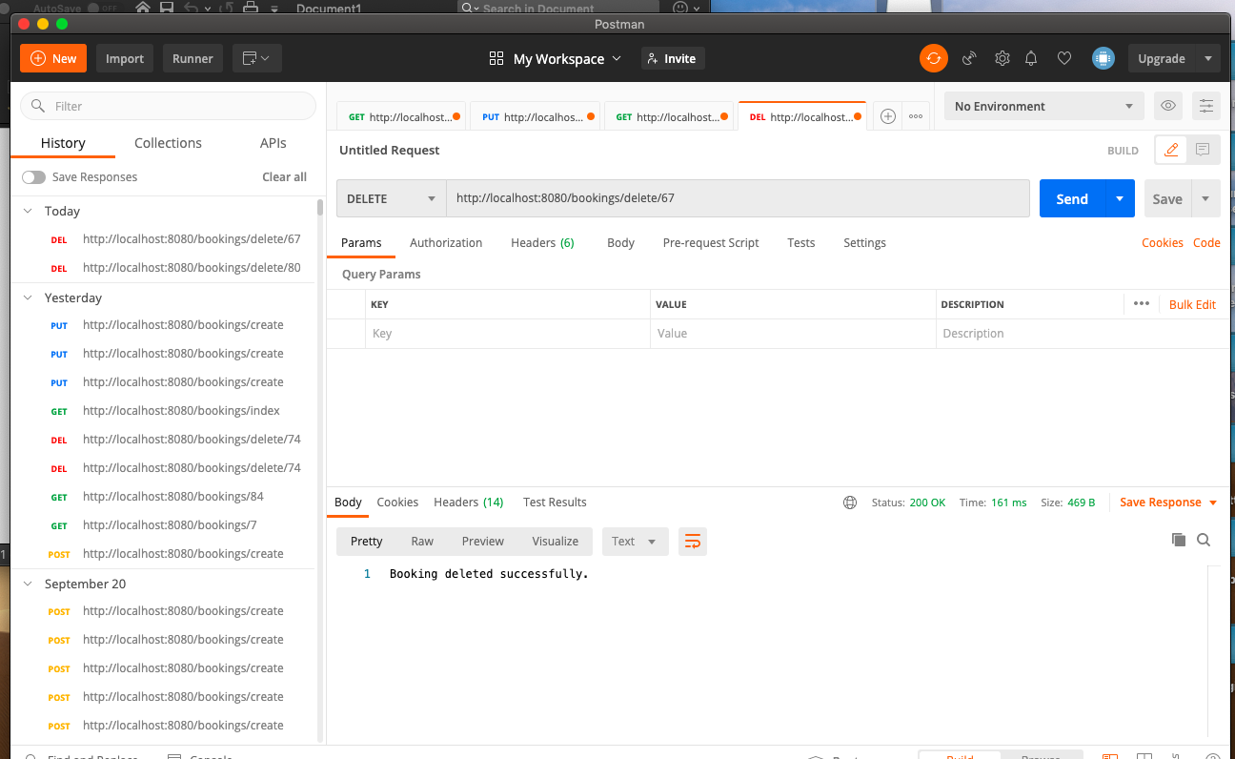

Acceptance test 29.4

Testing delete function again for the same booking to see if it was removed

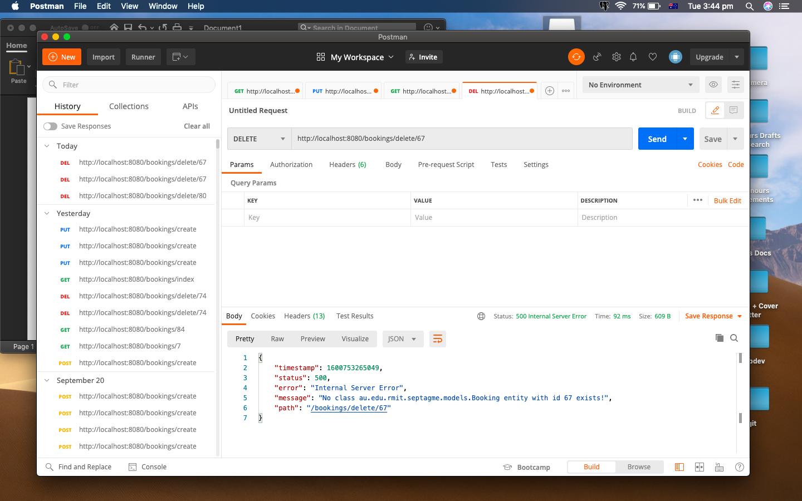

Testing non requirement feature to see if booking is linked to database

Finding booking by id

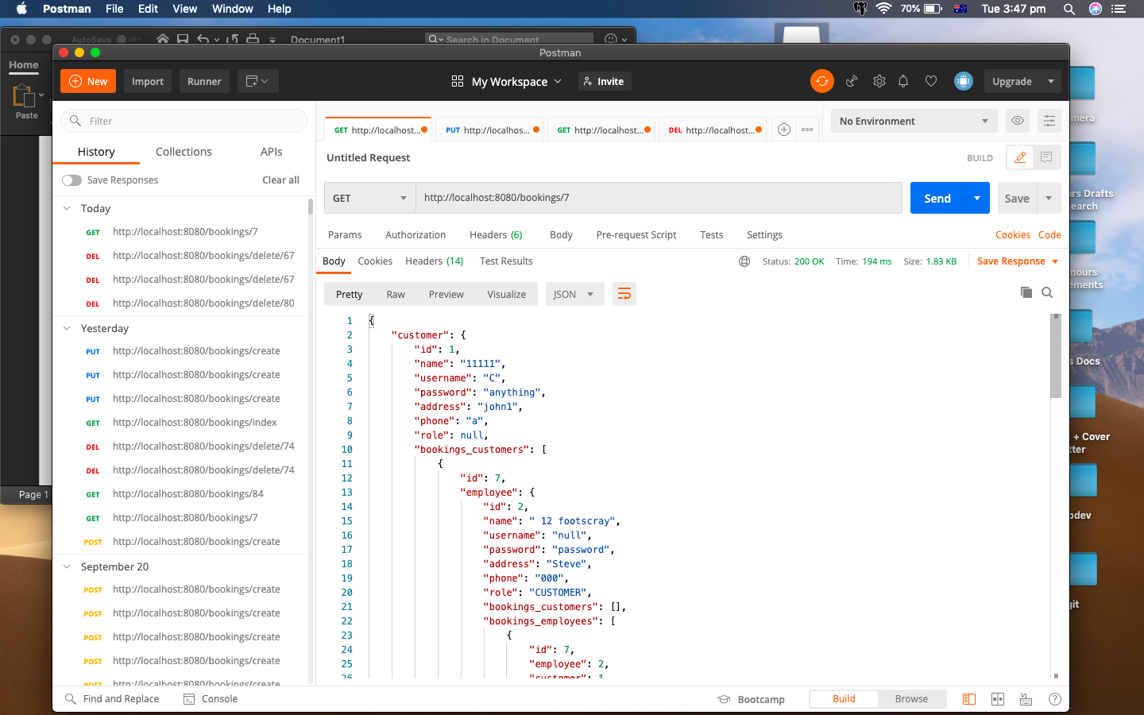

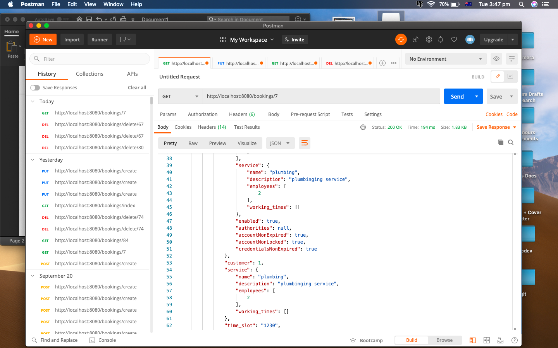

PBI 17

Acceptance test 17.1

Testing find all function bookings showing full data

